Unit 4: Software Development Model
Software Development life cycle (SDLC) is a spiritual model used in project management that defines the stages include in an information system development project, from an initial feasibility study to the maintenance of the completed application.
There are different software development life cycle models specify and design, which are followed during the software development phase. These models are also called "Software Development Process Models." Each process model follows a series of phase unique to its type to ensure success in the step of software development.
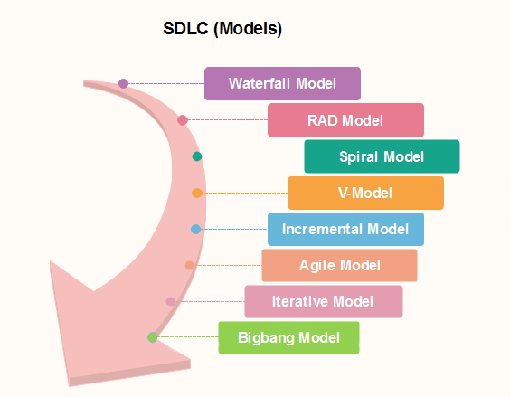

4.1 Waterfall Model
The waterfall is a universally accepted SDLC model. It is also referred as linear sequential life cycle model. In this method, the whole process of software development is divided into various phases. The waterfall model is a continuous software development model in which development is seen as flowing steadily downwards (like a waterfall) through the steps of requirements analysis, design, implementation, testing (validation), deployment, and maintenance.
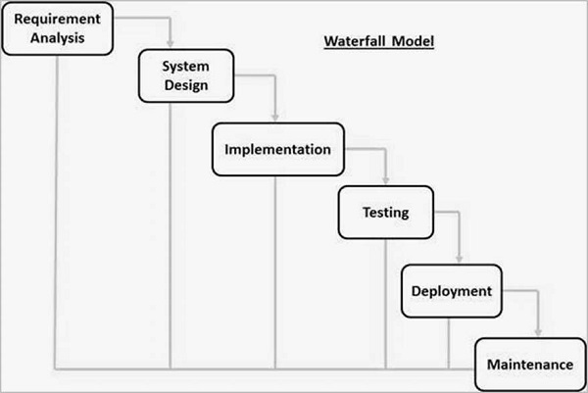
The sequential phases in Waterfall model are −
- Requirement Gathering and analysis − All possible requirements of the system to be developed are captured in this phase and documented in a requirement specification document.
- System Design − The requirement specifications from first phase are studied in this phase and the system design is prepared. This system design helps in specifying hardware and system requirements and helps in defining the overall system architecture.
- Implementation − With inputs from the system design, the system is first developed in small programs called units, which are integrated in the next phase. Each unit is developed and tested for its functionality, which is referred to as Unit Testing.
- Integration and Testing − All the units developed in the implementation phase are integrated into a system after testing of each unit. Post integration the entire system is tested for any faults and failures.
- Deployment of system − Once the functional and non-functional testing is done; the product is deployed in the customer environment or released into the market.
- Maintenance − There are some issues which come up in the client environment. To fix those issues, patches are released. Also to enhance the product some better versions are released. Maintenance is done to deliver these changes in the customer environment.
Advantages
Some of the major advantages of the Waterfall Model are as follows −
- Simple and easy to understand and use
- Easy to manage due to the rigidity of the model.
- Phases are processed and completed one at a time.
- Works well for smaller projects where requirements are very well understood.
- Clearly defined stages.
- Well understood milestones.
- Easy to arrange tasks.
- Process and results are well documented.
Disadvantages
The major disadvantages of the Waterfall Model are as follows −
- No working software is produced until late during the life cycle.
- High amounts of risk and uncertainty.
- Not a good model for complex and object-oriented projects.
- Poor model for long and ongoing projects.
- Not suitable for the projects where requirements are at a moderate to high risk of changing. So, risk and uncertainty is high with this process model.
- It is difficult to measure progress within stages.
- Cannot accommodate changing requirements.
- Adjusting scope during the life cycle can end a project.

4.2 Prototype Model
The prototype model requires that before carrying out the development of actual software, a working prototype of the system should be built. A prototype is a toy implementation of the system. A prototype usually turns out to be a very crude version of the actual system, possible exhibiting limited functional capabilities, low reliability, and inefficient performance as compared to actual software. In many instances, the client only has a general view of what is expected from the software product. In such a scenario where there is an absence of detailed information regarding the input to the system, the processing needs, and the output requirement, the prototyping model may be employed.

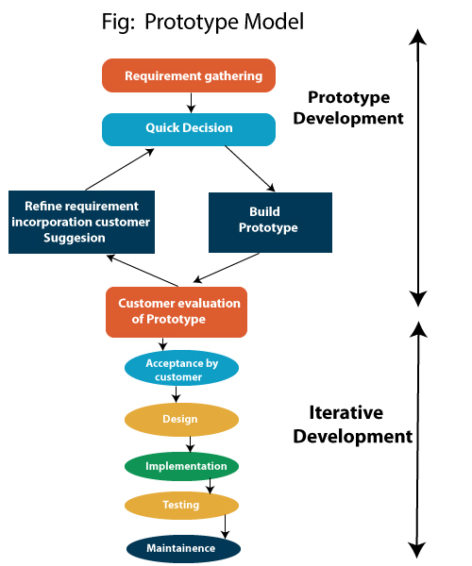

Steps of Prototype Model
- Requirement Gathering and Analyst
A prototyping model starts with requirement analysis. In this phase, the requirements of the system are defined in detail. During the process, the users of the system are interviewed to know what is their expectation from the system.
- Quick Decision
The second phase is a preliminary design or a quick design. In this stage, a simple design of the system is created. However, it is not a complete design. It gives a brief idea of the system to the user. The quick design helps in developing the prototype.
- Build a Prototype
In this phase, an actual prototype is designed based on the information gathered from quick design. It is a small working model of the required system.
- Assessment or User Evaluation
In this stage, the proposed system is presented to the client for an initial evaluation. It helps to find out the strength and weakness of the working model. Comment and suggestion are collected from the customer and provided to the developer.
- Prototype Refinement
If the user is not happy with the current prototype, you need to refine the prototype according to the user’s feedback and suggestions.
This phase will not over until all the requirements specified by the user are met. Once the user is satisfied with the developed prototype, a final system is developed based on the approved final prototype
- Engineer Product

Advantage of Prototype Model
- Reduce the risk of incorrect user requirement
- Good where requirement are changing/uncommitted
- Regular visible process aids management
- Support early product marketing
- Reduce Maintenance cost.
- Errors can be detected much earlier as the system is made side by side.

Disadvantage of Prototype Model
- An unstable/badly implemented prototype often becomes the final product.
- Require extensive customer collaboration
- Difficult to finish if customer withdraw
- May be too customer specific, no broad market
- Difficult to know how long the project will last.
- Prototyping tools are expensive.
- Special tools & techniques are required to build a prototype.
- It is a time-consuming process.

4.3 Spiral Model
Spiral model is one of the most important Software Development Life Cycle models, which provides support for Risk Handling. In its diagrammatic representation, it looks like a spiral with many loops. The exact number of loops of the spiral is unknown and can vary from project to project. Each loop of the spiral is called a Phase of the software development process. The exact number of phases needed to develop the product can be varied by the project manager depending upon the project risks. As the project manager dynamically determines the number of phases, so the project manager has an important role to develop a product using the spiral model.
Each phase of the Spiral Model is divided into four quadrants as shown in the above figure. The functions of these four quadrants are discussed below-
Objectives determination and identify alternative solutions: Requirements are gathered from the customers and the objectives are identified, elaborated, and analyzed at the start of every phase. Then alternative solutions possible for the phase are proposed in this quadrant.
Identify and resolve Risks: During the second quadrant, all the possible solutions are evaluated to select the best possible solution. Then the risks associated with that solution are identified and the risks are resolved using the best possible strategy. At the end of this quadrant, the Prototype is built for the best possible solution.
Develop next version of the Product: During the third quadrant, the identified features are developed and verified through testing. At the end of the third quadrant, the next version of the software is available.
Review and plan for the next Phase: In the fourth quadrant, the Customers evaluate the so far developed version of the software. In the end, planning for the next phase is started.
Note: The Spiral model is called a Meta-Model because it subsumes all the other SDLC models. For example, a single loop spiral actually represents the Iterative Waterfall Model. The spiral model incorporates the stepwise approach of the Classical Waterfall Model. The spiral model uses the approach of the Prototyping Model by building a prototype at the start of each phase as a risk-handling technique.
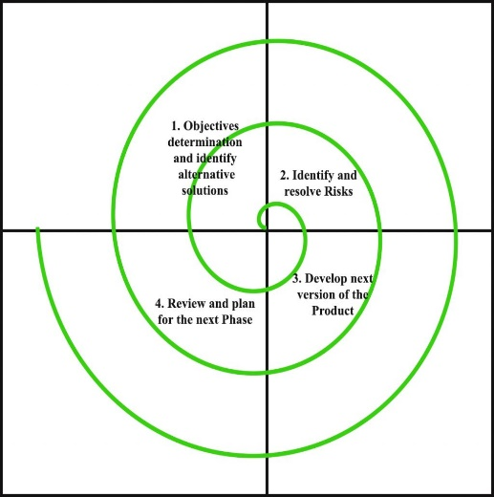
Advantages of Spiral Model:
Below are some advantages of the Spiral Model.
Risk Handling: The projects with many unknown risks that occur as the development proceeds, in that case, Spiral Model is the best development model to follow due to the risk analysis and risk handling at every phase.
Good for large projects: It is recommended to use the Spiral Model in large and complex projects.
Flexibility in Requirements: Change requests in the Requirements at later phase can be incorporated accurately by using this model.
Customer Satisfaction: Customer can see the development of the product at the early phase of the software development and thus, they habituated with the system by using it before completion of the total product.
Disadvantages of Spiral Model:
Below are some main disadvantages of the spiral model.
Complex: The Spiral Model is much more complex than other SDLC models.
Expensive: Spiral Model is not suitable for small projects as it is expensive.
Too much dependability on Risk Analysis: The successful completion of the project is very much dependent on Risk Analysis. Without very highly experienced experts, it is going to be a failure to develop a project using this model.
Difficulty in time management: As the number of phases is unknown at the start of the project, so time estimation is very difficult.

4.4 RAD (RAPID APPLICATION DEVELOPMENT)
Rapid application development is a software development methodology that uses minimal planning in favor of rapid prototyping. If the requirements are well understood and described, and the project scope is a constraint, the RAD process enables a development team to create a fully functional system within a concise time period.

Following are the various phases of the RAD Model −

Business Modelling
The business model for the product under development is designed in terms of flow of information and the distribution of information between various business channels. A complete business analysis is performed to find the vital information for business, how it can be obtained, how and when is the information processed and what are the factors driving successful flow of information.

Data Modelling
The information gathered in the Business Modelling phase is reviewed and analyzed to form sets of data objects vital for the business. The attributes of all data sets is identified and defined.

Process Modelling

The information object defined in the data modeling phase are transformed to achieve the data flow necessary to implement a business function. Processing descriptions are created for adding, modifying, deleting, or retrieving a data object.\

Application Generation
The actual system is built and coding is done by using automation tools to convert process and data models into actual prototypes.

Testing and Turnover
The overall testing time is reduced in the RAD model as the prototypes are independently tested during every iteration. However, the data flow and the interfaces between all the components need to be thoroughly tested with complete test coverage. Since most of the programming components have already been tested, it reduces the risk of any major issues.
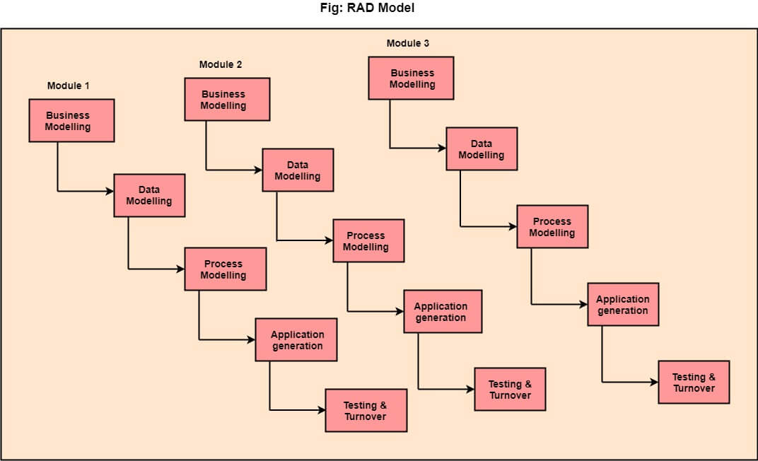

When to use RAD Model?
- When the system should need to create the project that modularizes in a short span time (2-3 months).
- When the requirements are well-known.
- When the technical risk is limited.
- When there's a necessity to make a system, which modularized in 2-3 months of period.
Advantage of RAD Model
- This model is flexible for change.
- In this model, changes are adoptable.
- Each phase in RAD brings highest priority functionality to the customer.
- It reduced development time.

Disadvantage of RAD Model
- It required highly skilled designers.
- All application is not compatible with RAD.
- For smaller projects, we cannot use the RAD model.
- On the high technical risk, it's not suitable.

